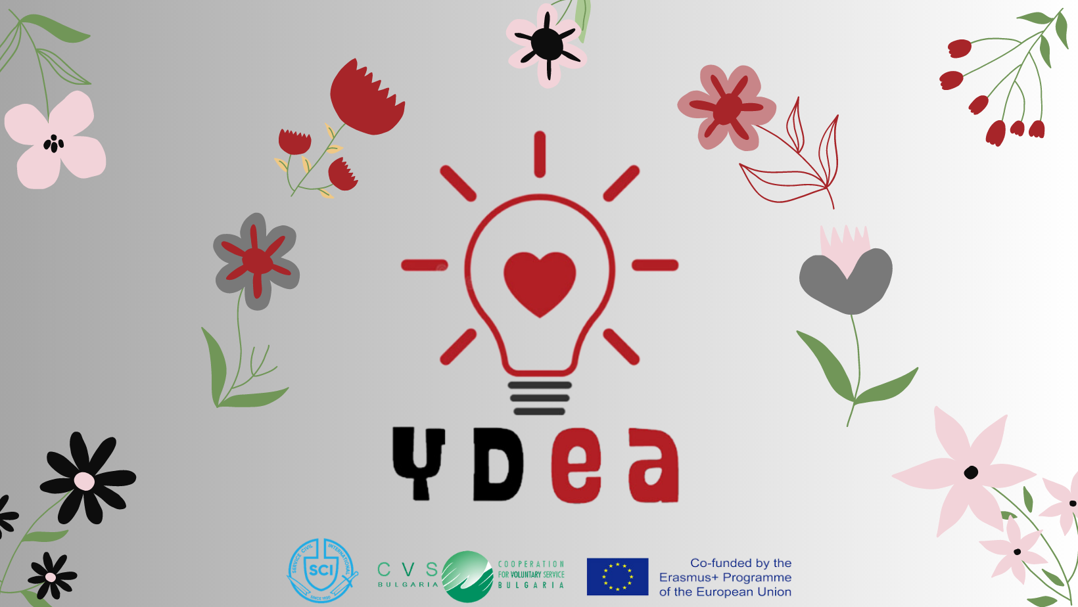

**Training Course “Y.D.E.A.”**

**Youth Development through Emotional Awareness”**

# 9-16 June 2023

**Emen village, Veliko Tarnovo region, BULGARIA**

# CALL FOR PARTICIPANTS

*for educators and trainers (also to-be trainers), leaders, volunteers, youth workers, staff and board members of no-profit organisations*

**from Austria, Bulgaria, Czech Republic, Estonia, Germany, Ireland, Italy, North Macedonia, Poland, Portugal, Slovakia, Slovenia, Spain and Turkey**

✔ Are you interestedin **emotional intelligence, social psychology** and **emotional awareness**?

✔ Do you want to know more about **Social and Emotional Learning** (SEL)?

✔ Are you willing to develop your **facilitation** and **non-formal education** skills addressed to youth?

✔ Do you want to learn more about how to improve the impact of your **non-formal activities** and **youth work** (workshops, webinars, workcamps, training courses...) through emotional intelligence and emotional awareness?

✔ Are you motivated to explore more about **social inclusion**?

✔ Are you committed to developing together a great educational output (“**emotional cards**”) based on the topics of the training course?

✔ Are you a **resident** of Austria, Bulgaria, Czech Republic, Estonia, Germany, Ireland, Italy, North Macedonia, Poland, Portugal, Slovakia, Slovenia, Spain or Turkey?

✔ Are you ready to meet **amazing people from 14 countries**, make new friendships, and get inspired by their ideas and projects?

✔ Would you like to enjoy **nature** spending a week in a peaceful green environment and having the possibility to explore the picturesque Veliko Tarnovo town?

✔ …And all this **without any cost**?!

If your answers are "Yes, this is me!", then...

**... we have an offer for you!! :-)**



**ABOUT US**

**Service Civil International** is the oldest voluntary peace movement in the world, with over 100 years of experience. Our mission is to promote a culture of peace by organising international volunteering projects with local and global impact. We are present in 40 countries on 5 continents, and we cooperate with partners in almost all countries of the world. Read more [here](http://www.sci.ngo).

During over 100 years of operating globally, SCI has accumulated lots of expertise in non-formal education and peacebuilding, which had been recognised by many institutions, including UNESCO and the Council of Europe. And did you know that SCI was even nominated numerous times for the Nobel Peace Prize?!

**CVS-Bulgaria** is the Bulgarian branch of SCI. CVS-Bulgaria promotes the development of societal values and encourages responsible behaviors towards peace, social justice, and nature protection culture. This is achieved by organising volunteer initiatives and educational programmes.

Learn more about CVS here and don’t forget to like us on [facebook](https://web.facebook.com/CVS.Bulgaria/) and follow us on [Instagram](https://www.instagram.com/cvsbulgaria/)!



**THE PROJECT IN SHORT**

The main aim of this project is to equip participants with skills and knowledge in the field of Emotional Intelligence, Social Emotional Learning and Emotional Awareness to promote more effectively youth development and social inclusion. Read more about our project [here](https://cvs-bg.org/ydeaeng/?lang=en) and have a look at the summary below!

**The project has 4 main components:**

**1. 90-minute preparatory online meeting and digital preparatory tasks (May 2023)**

The online meeting will be held a few weeks before the beginning of the training course. It will last 90 minutes and will involve the participants, the trainers and the representatives of CVS-Bulgaria. It will be a chance to start getting to know one another, to share details on the project, the venue and the logistics, and to answer questions. Participants will be invited to perform creative preliminary tasks, using an online platform such as “Padlet”, which will help them understand the topics to be addressed during the training course.

#### 2. Y.D.E.A. Training Course (9 - 16 June 2023, Emen, Bulgaria)

Each day of the training course will include 4 non-formal education sessions, which will involve participants in creative, interactive and awareness-raising activities focused on Emotional Intelligence. The trainers will propose team-building activities, group-work, “learning-by-playing” sessions, spaces for learning, sharing, evaluating and reflecting. There will be the chance to relax, meet local organisations and visit the surrounding area.

#### 3. Participative development of the output – “Emotional Cards” (after the training course)

During the last day of the training course, participants will start developing the “Emotional Cards”, a creative non-formal education tool which will help youth workers to boost emotional intelligence, social inclusion and social emotional learning in their activities. The development of the output will continue online through a participative effort of the whole group and under the coordination of CVS Bulgaria.

**4. Final online meeting to present and disseminate the project results**

The Final Online Meetingwill be a 1-hour online event planned at the end of the year / beginning of 2024, to officially launch the tools and presenting the project results and impact.



**THE TRAINING COURSE**

### We are ready to invite you to join a one-week training course "Y.D.E.A.", which will take place between 9th and 16th June 2023 in Emen village, Veliko Tarnovo region, Bulgaria.

**At the training, you will:**

* get to know and learn more about the international participants and their organisations, through team-building and interactive sessions;
* increase your knowledge on Emotional Intelligence, Social Emotional Learning, Emotional Awareness, social psychology, mental health and how to apply this knowledge to youth work to boost social inclusion and impact;
* through “learning-by-playing” sessions, develop non-formal educational methods, tools, models and practice based on SEL and EI, and focused on the current needs of young people;
* develop and consolidate sensitivity and the expertise concerning mental health issues within the organisations, the networks, the International Voluntary Service movement and in youth work in general;
* share ideas and inspirations on how to create synergies with formal and non-formal education bodies, to reach-out and include young people with fewer opportunities.

The provisional training programme can be found on the last page of this call.

We will offer you **an excellent learning opportunity** that will support you to increase the quality of non-formal education activities you and your organisation are doing, and also **a unique networking experience** with fellow-minded people from across Europe. *Please read the following points to check if you are eligible to apply!*



**FOR WHOM**

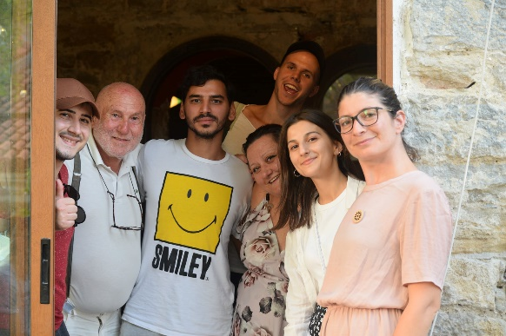

The ideal participants are educators and trainers (also to-be trainers), workcamp coordinators, volunteers, NGOs staff and board members and youth workers with an interest in emotional intelligence, mental-health, non-formal education, social inclusion and its applications in their work with young people.

**There are a few formal requirements you need to satisfy to join the training course:**

1. You need to be a **resident of one of the 14 project countries** mentioned on the cover page.
2. You must be able to **communicate in English** (the working language of the course).
3. You must be **at least 18 years of age**.
4. You need to **attend the whole course duration** (there is no possibility to make exceptions).
5. You commit yourself to take part in the preparatory and in the follow-up phase of the project.

**We explicitly encourage participants of all genders, abilities and ethnic backgrounds to apply!**

#### 

#### WHEN

The training course will last 7 days (not counting departure day).

You need to **arrive** to Veliko Tarnovo on **Friday, 9th June 2023 before 4 p.m**. The meeting point for the organized transport to the village will be announced later to the selected participants.

The course finishes on 15th June 2023, in the late evening, therefore, **departures** are planned for the **morning of Friday, 16th June 2023** (breakfast is included).



#### WHERE

The training course will take place in [Hotel Imenieto,](http://imenieto.com/en/) which is situated in Emen ([Bulgarian](https://en.wikipedia.org/wiki/Bulgarian_language): Емен) - a small village located near the old Bulgarian capital - Veliko Tarnovo. The place is famous for the canyon and waterfalls nearby.

Veliko Tarnovo – unique in its architecture and historical importance – is only 20 km away.

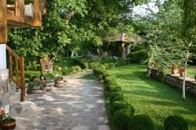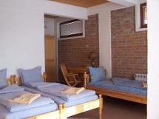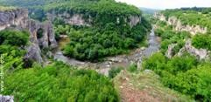

The accommodation will be organized in double or triple rooms (in small family houses) which have a private bathroom, bed-linens and towels, and free Wi-Fi. There are many possibilities to enjoy the free time in the place - table tennis, swimming pool, volleyball, walk in nature or just relax in the green garden.



**METHODS & CONTENTS**

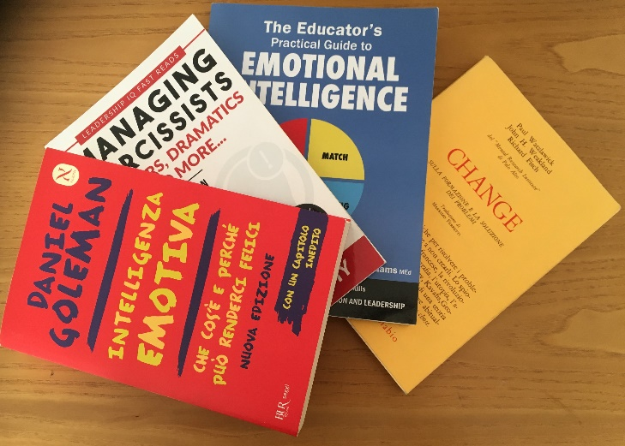Our working methods will be based on the principles of non-formal education and experiential learning, creating a stress-free and motivating environment where the human brain has a full capacity to learn. You will often work in smaller groups to achieve the best results. All the methods will encourage active participation, creativity, initiative and responsibility for one's learning process. The training course contents are inspired by the theories of Daniel Goleman, the “4M Model” by Caruso, Rees and Adams, and Paul Watzlawick, which will be presented through interactive activities, creative presentations and awareness-raising sessions.



## MEET THE TRAINERS

We are happy to announce that the training course will be facilitated by experienced and certified trainers, experts in adult education, and – at the same time – peace activists.

***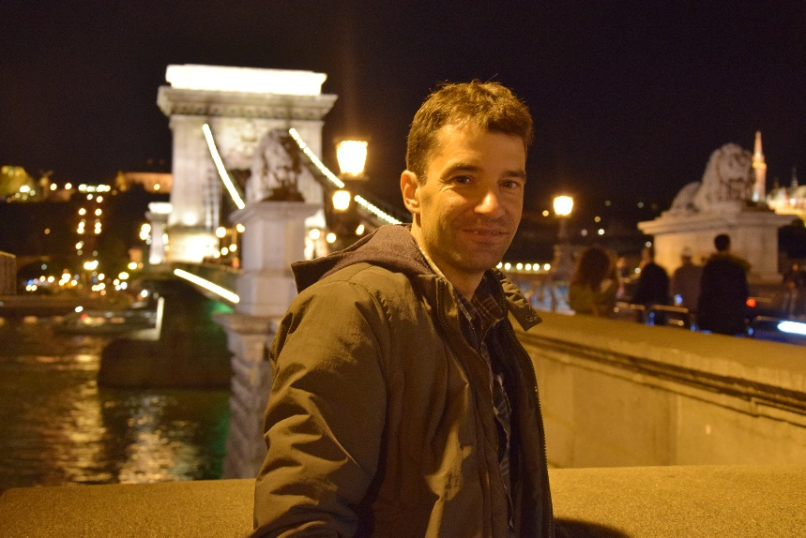*Mauro Carta, Italy**: Mauro is a free-lance trainer and project manager, with a degree in European Studies and Education Science and a long experience of cooperation with IVS organisations. He designed and implemented several youth projects, including training and seminars on different topics: project management, youth work, non-formal education, impact measurement. Furthermore, Mauro has coordinated workcamps in Europe, Africa and Australia.

#### Katerina Stoyanova, Bulgaria: Katerina has a solid and proven track record experience in the development, implementation and evaluation of educational projects, courses and seminars. With her organisation CVS Bulgaria, Katerina has managed several projects featuring non-formal education as a tool for the inclusion of members of the local community. She has recently obtained a Master degree in "Social work with Refugees and Migrants" and has lately enrolled in Arabic studies master program in Sofia University.

## CERTIFICATES

You will be awarded a training completion certificate, issued by CVS-Bulgaria; additionally, you will receive a Youthpass certificate.



## FINANCIAL CONDITIONS

#### Food and accommodation as well as all organisational costs (additional insurance, training materials, etc.), will be fully covered thanks to the co-financing by the European Union.

CVS-Bulgaria runs this project in a partnership with SCI Italy, SCI Austria, SCI Germany, OWA Poland, Zavod Voluntariat (Slovenia), VSI Ireland, EstYES (Estonia), Para Onde (Portugal), CID (Republic of North Macedonia), Xeracion Valencia (Spain), EYCB (Czech Republic), System & Generation (Turkey), Youth for Equality (Slovakia).

#### Some of the partners may ask for a small sending fee to cover their placement costs.

Please check with the relevant organisation.

**Reimbursement of the travel tickets** will be 100% up to the maximum amounts after the receipt of the original documents. Maximum travel reimbursement will be according to the following Erasmus+ rates[1]:

|  |  |  |  |
| --- | --- | --- | --- |
| Country | Number of participants | Max. Reimbursement (Flight) | Max. Reimbursement (Green Travel) |
| Austria | 3 | 275 € | 320 € |
| Bulgaria | 3 | 23 € | 23 € |
| Czech Republic | 2 | 275 € | 275 € |
| Estonia | 1 | 275 € | 275 € |
| Germany | 2 | 275 € | 275 € |
| Ireland | 2 | 360 € | 360 € |
| Italy | 1 | 275 € | 275 € |
| North Macedonia | 2 | 180 € | 210 € |
| Poland | 2 | 275 € | 275 € |
| Portugal | 2 | 360 € | 360 € |
| Slovakia | 2 | 275 € | 275 € |
| Slovenia | 2 | 275 € | 275 € |
| Spain | 2 | 360 € | 360 € |
| Turkey | 2 | 275 € | 320 € |

If you are from Austria, North Macedonia and Turkey and you choose **green travel** (meaning: you will not travel by airplane or boat, but you will use bus, train, car sharing), you can receive reimbursement of additional accommodation costs on the way to Emen, as well as reimbursement of small expenses made while travelling.

Even though this is not a “getting to know Bulgaria” project, **you may also stay in Bulgaria a few days before or after at your private expense**, as long as the travel cost is not higher than the cost which you would bear if coming only for course duration - otherwise you will be asked to cover the difference.

Please be aware that we do not cover the costs of COVID tests, should you need one.

## 

## SUSTAINABILITY

The food we provide will be mainly vegetarian and locally produced. We organize our coffee breaks trying to use mainly bio products and fare trade coffee and tea. We use recycled paper and avoid plastic in our trainings, as well as we encourage our participants to recycle.We encourage you to use environmentally friendly transport (bus, train, car sharing) when possible, and we will explicitly ask participants from Austria, North Macedonia and Turkey to choose this type of transport instead of a plane (as agreed by SCI Austria, CID and System & Generation when establishing the partnership). Questions or doubts? Contact us!



**HOW TO APPLY**

**If you consider yourself a suitable candidate for the course, please fill in the** [**application form**](https://docs.google.com/forms/d/e/1FAIpQLSduROD_DK8Q_F5h-Zrer1n0iPcKR0NLUui2ppI3zn2lA1bjAQ/viewform) **by 16.05.2023, 23:59 CEST**.

Before submitting your application, please contact the partner who will act as sending organization (click on the organization name to consult its website):

|  |  |
| --- | --- |
| Country | Organisation |
| Austria | [SCI Austria](http://www.sciaustria.org) |
| Bulgaria | [CVS Bulgaria](http://cvs-bg.org/) |
| Czech Republic | [EYCB](http://www.eycb.eu) |
| Estonia | [EstYES](http://www.estyes.ee) |
| Germany | [SCI Germany](http://www.sci-d.de) |
| Ireland | [VSI](http://www.vsi.ie) |
| Italy | [SCI Italy](http://www.sci-italia.it) |
| North Macedonia | [CID](http://www.cid.mk) |
| Poland | [OWA](http://www.jedenswiat.org.pl) |
| Portugal | [Associação Para Onde?](http://www.paraonde.org) |
| Slovakia | [Youth for Equality](http://www.youthforequality.sk) |
| Slovenia | [Zavod Voluntariat](http://www.zavod-voluntariat.si) |
| Spain | [Xeracion Valencia](http://www.xeracionvalencia.org) |
| Turkey | [System & Generation](http://www.systemandgeneration.com) |

You will be notified of the selection results by **20.05.2023.**

All those accepted will receive a detailed infosheet (including how to get to the venue, how to book your travel, what to bring, more information about the agenda of the project and details about the preparatory tasks). We will support you in the pre-departure phase together with our project Partner Organisations. Please do not start booking tickets before receiving the official confirmation of approval by CVS-Bulgaria!



**ANY QUESTIONS?**

If you have further questions regarding the project, you can write to us at **trainings@cvs-bg.org**

***We are looking forward to your application!***

#### The coordinating team

**Kat & Mauro**

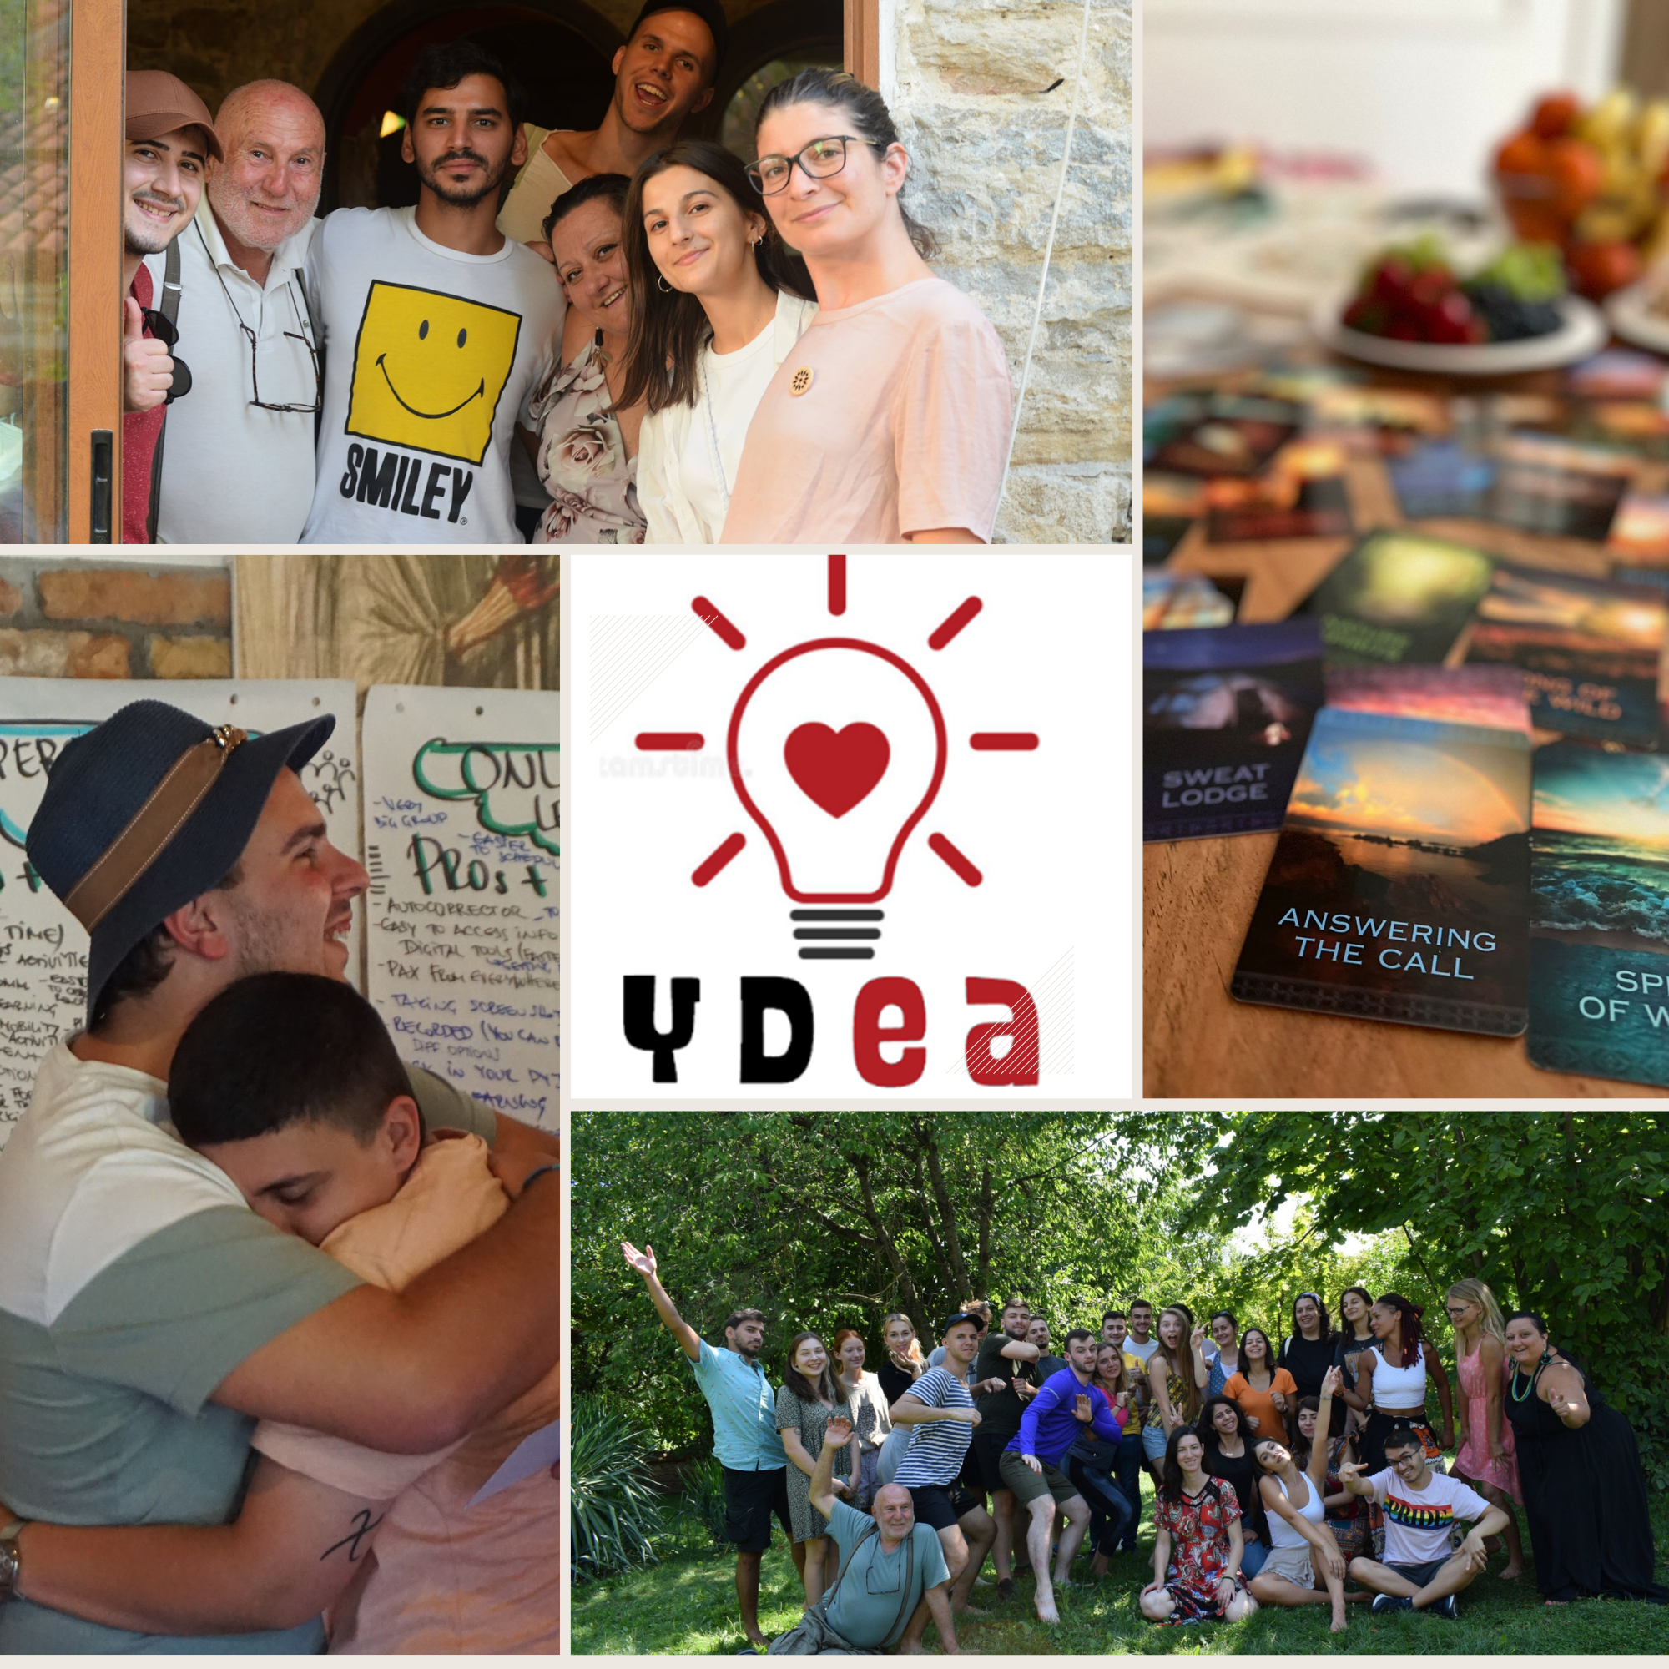

**Provisional programme of the Y.D.E.A. Training Course by CVS-Bulgaria, 9-16.06.2023, Emen village, Veliko Tarnovo region, Bulgaria**

|  |  |  |  |  |  |  |  |
| --- | --- | --- | --- | --- | --- | --- | --- |
| **DAY** | **1 – Fri, 09.06** | **2 – Sat,10.06** | **3 – Sun, 11.06** | **4 –Mon, 12.06** | **5 – Tue, 13.06** | **6 – Wed, 14.06** | **7 – Thu, 15.06** |
| **08:00-9:30** |  | ***Breakfast at 8:00*** | | | | | |
| **9:30-11:00** | Project & Training Overview | What do we know about emotions? (part 1) | The 4Ms model: theory and group work to practice EI and SEL on real cases | Techniques to include  EI and SEL in our NFE activities | The 5 SEL (Social Emotional Learning) core competences | Participatory Design and development of the output: the Emotional Cards |
| **11:00-11:30** | ***Break*** | | | | | |
| **11:30-13:00** | Expectations, fears, contributions | What do we know about emotions? (part 2) | Crossroads: challenging emotional situations in youth work | From theory to practice: how can we make the most of EI in our personal and  Professional life? | Promoting effective communication: assertiveness, NVC, constructive feedback | Participatory Design and development of the output: the Emotional Cards |
| **13:00-15:00** |  |  |  |  | ***Lunch at 13:00*** |  |  |
| **15:00-16:30** | 16:00  Meeting point in Veliko Tarnovo | Team building  activity | Current young people's challenges and impact on their mental health | Mid evaluation and Youthpass | Stress management | Networking  Space | What’s next: Timeline and plan of action |
| **16:30-17:00** |  | ***Break*** | | | | | |
| **17:00-18:00** | 17:00 - Opening of the training & Getting to know the group  and the place | Presentation of participants' organisations, fields of actions, relevant projects | Emotional Intelligence and Social Emotional Learning: what are they and why do  we need them in youth work? | Free afternoon | Learning by Playing: group games to foster social inclusion and emotional intelligence | Learning by Playing: group games to foster social inclusion and emotional intelligence | Final Evaluation & Closure of the training |
| **18:00-18:30** | Reflection teams | | Reflection teams | |
| **18:30-20:00** | ***Dinner at 19:00*** | | | | | | |
| **20:00- ∞** | Welcome evening | Games evening | Movie evening | Free evening | Open mic evening | Participants evening | Certificate awarding ceremony*,*  Emotional Party |

**Departures** from the training venue are foreseen for Wednesday, 16th June 2023, after breakfast.

The **final programme** may be slightly modified depending on the profile of selected participants and their specific needs and interests.

1. travel by plane: distance 100-499 km up to 180 euro, 500-1999 km up to 275 euro;

   green travel (bus, train, car sharing): distance 100-499 km up to 210 euro, 500-1999 km up to 320 euro.